You have a list of points in the plane. Return the area of the largest triangle that can be formed by any 3 of the points.

**Example:**

**Input:** points = [[0,0],[0,1],[1,0],[0,2],[2,0]]

**Output:** 2

**Explanation:**

The five points are show in the figure below. The red triangle is the largest.

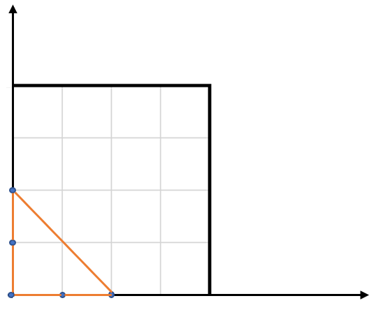

**Notes:**

* 3 <= points.length <= 50.
* No points will be duplicated.
* -50 <= points[i][j] <= 50.
* Answers within 10^-6 of the true value will be accepted as correct.